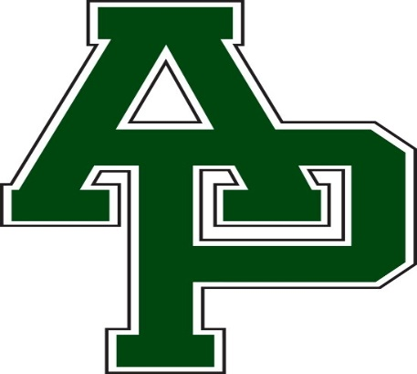

**Allen Park Public Schools**

Elementary

U

