**WHAT MAKES A MEAL?**

**Breakfast:**

**All Students are Offered 4 Food Components**

A student may choose all 4 components or may decline up to 1 components and take only 3 components.

Students MUST take at least ½ cup of either a fruit or a vegetable.

*O* Skim Milk

*O* White or reduced sugar, no HFCS chocolate

*O* Fruit or Vegetable

*O* ½ cup serving

*O* **Grain**

*O* Some entrees are two grains

AND/OR

*O* Meat/Meat Alternate or Second Grain

*O* Some entrees are a grain & a protein

1. Fruits or

Vegetable

*\*½ cup serving\**

1. Grain

*Note – Entrées can contain two grains*

* 1. Skim Milk

*\*Choose white or reduced sugar, no HFCS chocolate\**

**Utensils**

1. Meat/Meat Alternative

*Note – Entrées can contain both

a protein & a grain.

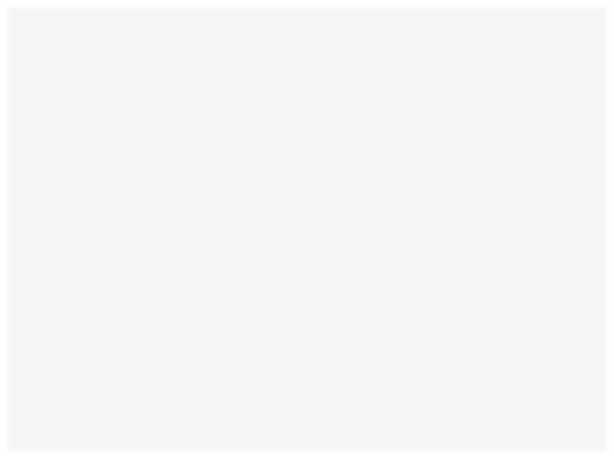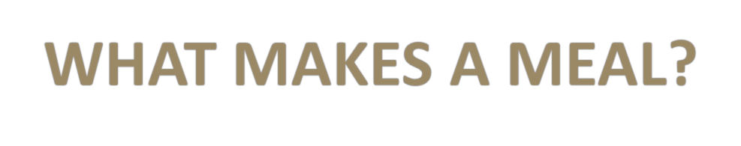

***\*This institution is an equal opportunity provider\****