

WINTER BREAK
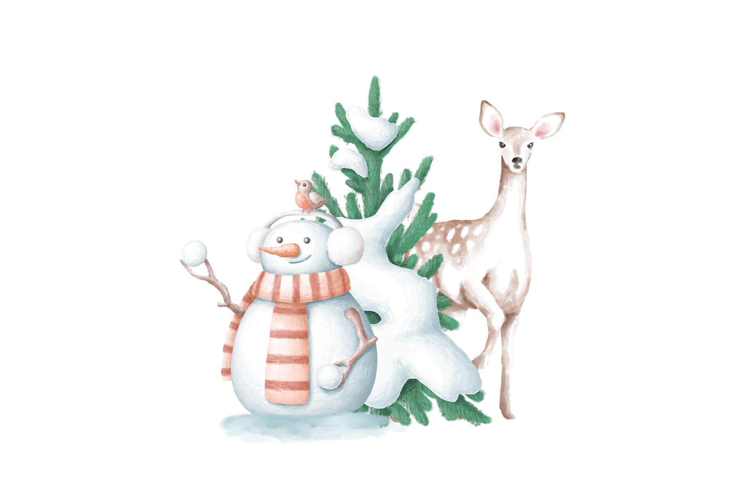
WINTER BREAK

WINTER BREAK

*CHIPOLTE BOWLW/ROLL
*SPICY CHICKEN OR PLAIN CHICKEN SANDWCH, *PIZZA
*POPCORN CHICKEN WRAP TO GO
*ITALIAN SALAD WITH ROLL
*STREET CORN, *SLICED ORANGES
*CINNAMON GOLD FISH
*MILK

DAILY OFFERINGS
*PIZZA*
*HOT SANDWICH*
*COLD SANDWICHES*
APPLE/GRAPE JUICE AVAILABLE DAILY
USDA is an equal opportunity provider, employer, and lender. Variety of milk available. MENU SUBJECT TO CHANGE
WINTER BREAK

WINTER BREAK
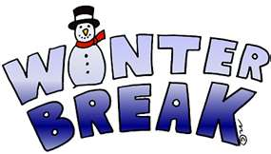
*CHICKEN PARMESAN SANDWICH
WITH ROTINI MARINARA
*WESTERN BACON CHEESEBURGER
*PIZZA, *TURKEY/CHEESE SUB
*CHEF SALAD WITH ROLL
*FRESH BROCCOLI WITH DIP
*FRESH LUNCH BUNCH GRAPES
*BROWNIE, *MILK

*MIDDIE MASH WITH DINNER
ROLL
*SPICY CHICKEN OR PLAIN CHICKEN SANDWICH, *PIZZA
*POPCORN CHICKEN WRAP TO GO
*ITALIAN SALAD WITH ROLL
*CORN
*MANDARINE ORANGES, * SCOOBY CHEW, *MILK

*PILLSBURY CHEESY GARLIC
PULL APARTS WITH SAUCE
*SLIDER BBQ PORK OR CHICKEN SANDWICH, *PIZZA
*ITALIAN WRAP TO GO KIT
*GRILLED CHICKEN CHEF SALAD WITH ROLL,*BLACK BEANS WITH QUESO,*SLICED ORANGES, *CHEDDAR GOLD FISH CRACKERS, *MILK

*BEEF PHILLY WITH FIXINS
*SPICY CHICKEN OR PLAIN CHICKEN SANDWICH
*PIZZA , *BLT WRAP TO GO
*CHICKEN CAESAR SALAD WITH ROLL
*FRESH BABY CARROTS WITH DIP
*FRESH APPLE SLICES,
*VANILLA ICE CREAM, *MILK

DECEMBER 2025
MIDVIEW HIGH SCHOOL
*CHILLI CHEESE FRIES/ROLL
*SPICY CHICKEN OR PLAIN CHICKEN SANDWICH
*PIZZA , *BLT WRAP TO GO
*CHICKEN CAESAR SALAD WITH ROLL
*FRESH BABY CARROTS WITH DIP
*FRESH APPLE SLICES,
*EMOJI TREAT, *MILK
*BUFFALO OR CHEESE
QUESEDILA
*MAC & CHEESE BURGER W/BACON *PIZZA
*ITALIAN WRAP TO GO KIT
*GRILLED CHICKEN CHEF SALAD WITH ROLL,*BLACK BEANS WITH QUESO,*SLICED ORANGES, *APPLE CRISP, *MILK

*MACARONI AND CHEESE/
DINNER ROLL
*SPICY CHICKEN OR PLAIN CHICKEN SANDWICH, *PIZZA
*POPCORN CHICKEN WRAP TO GO
*ITALIAN SALAD WITH ROLL
*CORN*MANDARINE ORANGES, * CHOCOLATE PUDDING W/WHIPPED TOPPING, *MILK
*DELUXE BURGER BAR
*SOFT PRETZEL HOT DOG
*PIZZA, *TURKEY/CHEESE SUB TO GO
*CHEF SALAD WITH ROLL
*FRESH BROCCOLI WITH DIP
*FRESH LUNCH BUNCH GRAPES
*FRESH CARNIVAL COOKIE, *MILK

*HOT CHICKEN WRAP
*SPICY OR PLAIN CHICKEN
SANDWICH
*CEASAR WRAP TO GO, *PIZZA
*BBQ CHICKEN SALAD WITH ROLL
* FRIES
*FRESH BERRIES
*TEDDY GRAHAMS *MILK

*FRENCH TOAST WITH EGG
OMLET
*SPICY CHICKEN OR PLAIN CHICKEN SANDWICH
*PIZZA,*GRILLED CHICKEN TACO WRAP TO GO, *CHICKEN CAESAR SALAD WITH ROLL
*TATOR TOTS,* FRESH APPLE,
*RICE KRISPY TREAT, *MILK

*ASIAN FUSION WITH RICE
AND SPRING ROLLS
*MEATBALL SANDWICH
*PIZZA, *BLT WRAP TO GO
*GRILLED CHICKEN CHEF SALAD WITH ROLL, *PETITE CARROTS
*GARDEN SALAD,
*MANDARINE ORANGES, *FORTUNE COOKIE W/ORANGE SHERBET, *MILK

*BBQ OR PEPPERONI
FLATBREAD
*HAMBURGER SLIDERS, *PIZZA
*TURKEY/CHEESE SUB TO GO
CHEF SALAD WITH ROLL
*BAKED BEANS, *FRESH LUNCH BUNCH GRAPES, FRESH CHOCOLATE CHIP COOKIE, MILK

*CHICKEN FAJITAS W/FIXINS
*SPICY OR PLAIN CHICKEN
SANDWICH
*ITALIAN SUB
*CEASAR WRAP TO GO, *PIZZA
*POPCORN CHEF SALAD WITH ROLL
*FRESH BERRIES, *S&P FRIES,
*SCOOBY TREAT, *MILK

*BOSCO STICKS W/SAUCE
*SPICY OR PLAIN CHICKEN
SANDWICH
*CEASAR WRAP, *PIZZA
*BBQ CHICKEN SALAD WITH ROLL
*STAZ FRIES
*FRESH BERRIES
*CHEEZ-ITS, *MILK

WINTER BREAK

WINTER BREAK

WINTER BREAK


