2026 USDA Milk Requirement Updates

- The milk variety check has been updated for lunch to allow reduced fat and whole milk. Reduced fat and whole milk will fail the breakfast check since they are not allowed. **Unflavored milk must still be offered as an option at breakfast and lunch**

USDA statement: “Milk varieties may be unflavored or flavored, provided that unflavored milk is offered at each meal service and that flavored milk does not exceed the added sugars limit.”
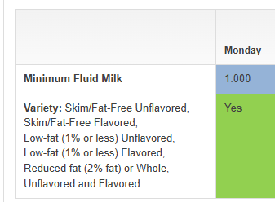

- Milk will be excluded from the lunch weekly average saturated fat requirement. Milk will still be included in all other dietary specifications including calories, sodium, and added sugar (effective July 1, 2027).
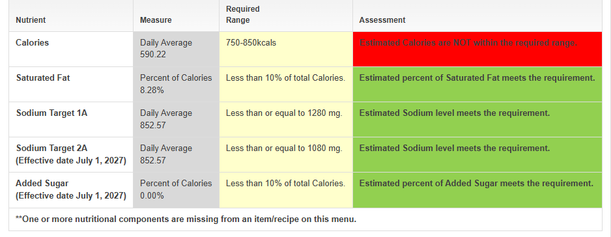
Important: For both changes to work correctly, users must input the correct Servings Planned Breakfast and Servings Planned Lunch on the milk items and select the correct Milk Type in Menu daily.

