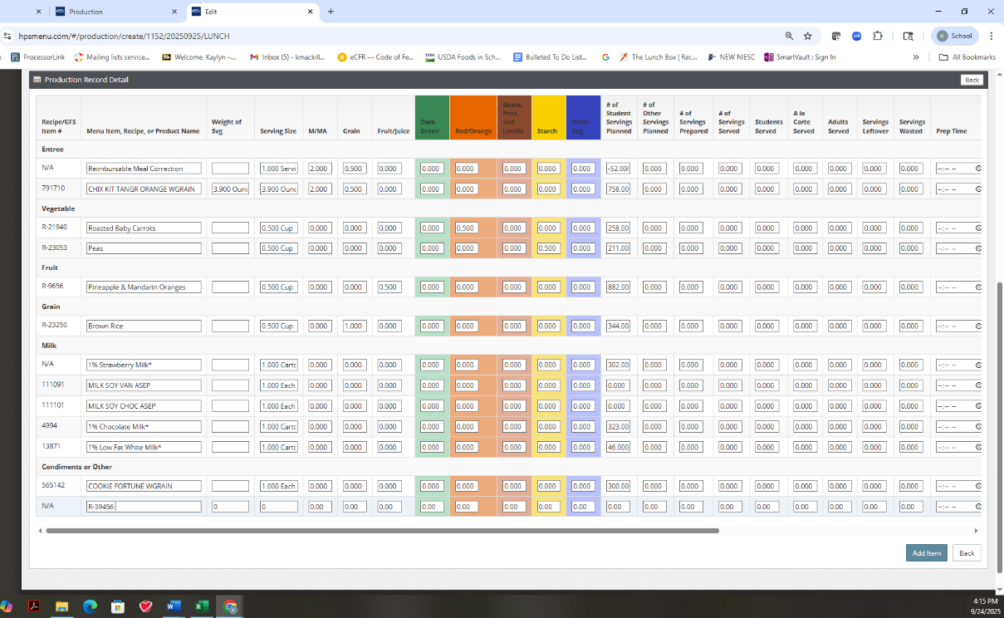
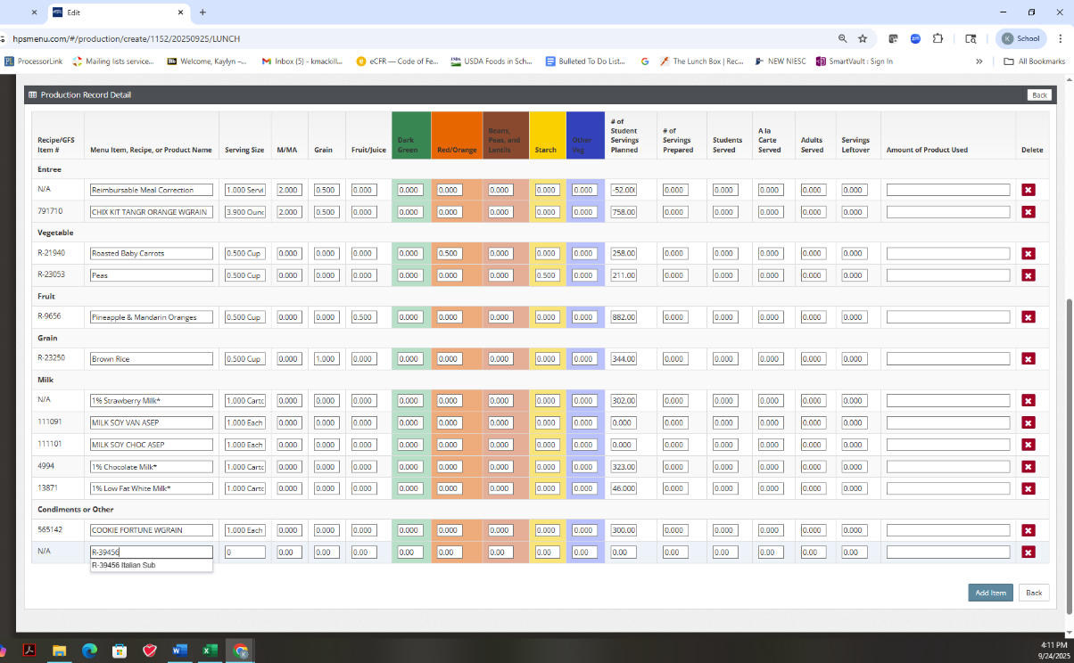
Signed in with “production” level authorization.
Signed in with “district” level authorization.

