Benton Jr.-Sr High School Week #6

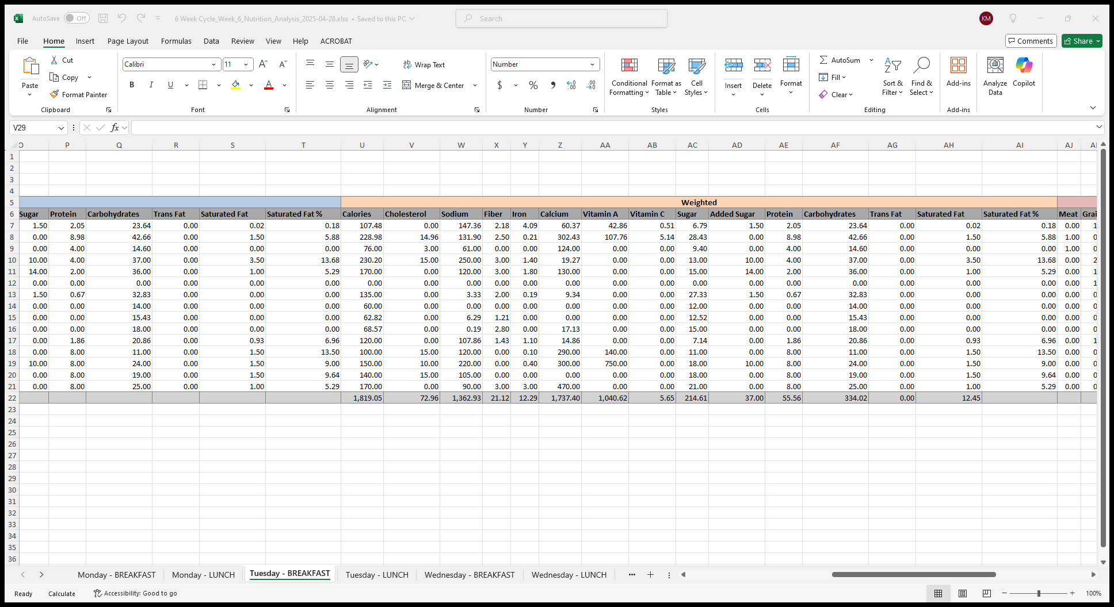



Benton Jr.-Sr. High School Week #4

