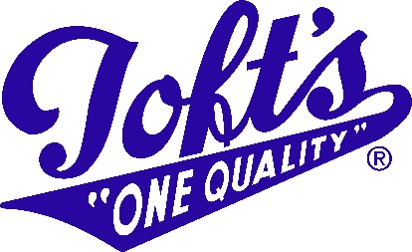

**Ohio’s Oldest Dairy, Since 1900**

**www.toftdairy.com**

**Toft’s Nonfat Chocolate Milk – Half Pint (8oz)**

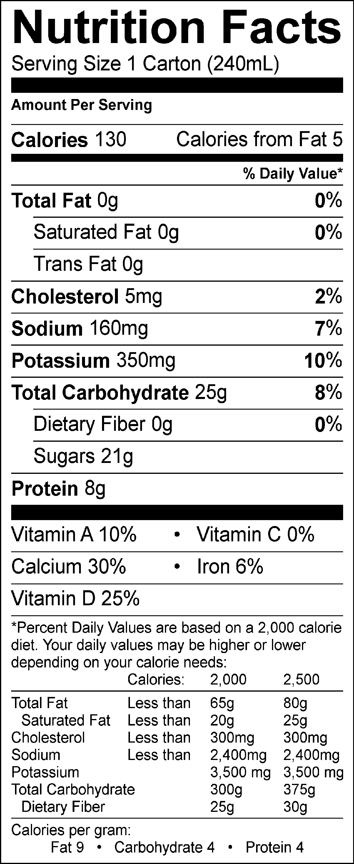

INGREDIENTS: GRADE A NONFAT MILK, SUGAR, CORN SYRUP, COCOA (COCOA PROCESSED WITH ALKALI, CORN STARCH, SALT, CARRAGEENAN, AND VANILLIN), VITAMIN A PALMITATE AND VITAMIN D3 ADDED.

TOFT DAIRY FARMERS PROMISE | Not to treat their cows with artificial growth hormones *

ALL MILK TESTED FOR ANTIBIOTICS

GLUTEN FREE

*The FDA has determined that no significant difference has been shown in milk from cows given and not given rBST.

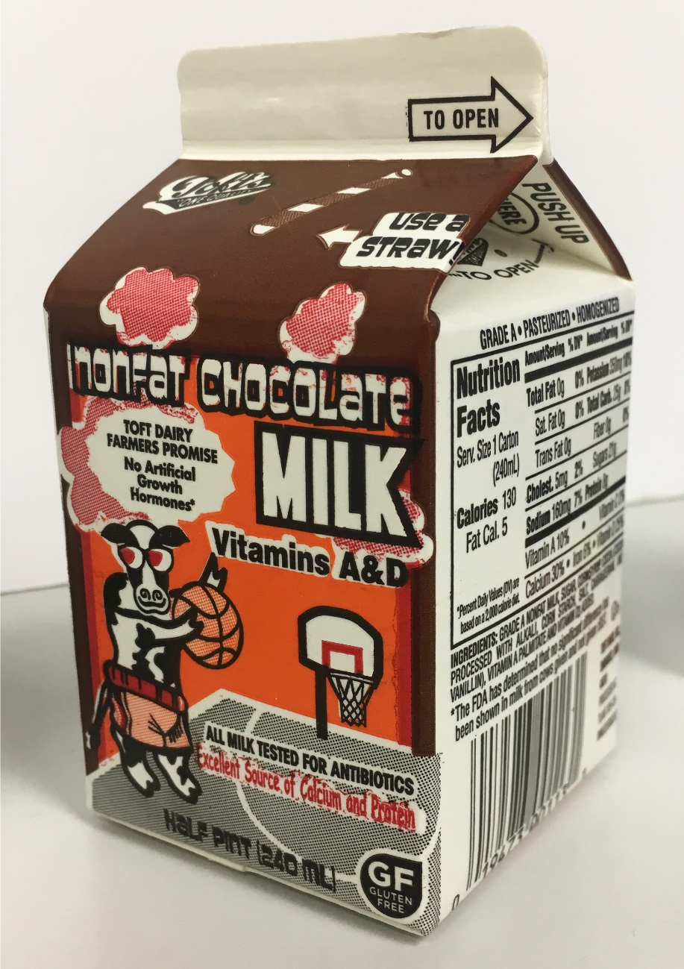

***** ALLERGEN ALERT: Contains - Milk

**Toft Dairy Product Code: 113**

