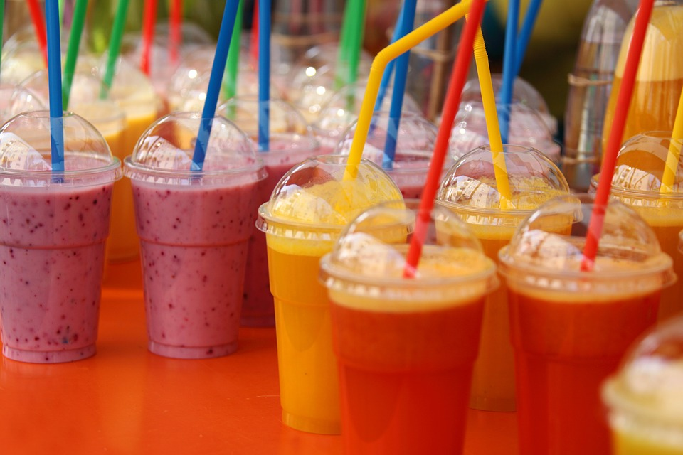

**Try a Smoothie for Breakfast!**

Take a Muffin, Cereal, Cracker, or Oatmeal Bar with your Smoothie to Make a Meal

Or

Buy as an Entrée $1.75