Pepperoni Pizza

Serving=8

**1 Pizza**

Recipe #600

Pizza

|  |  |  |  |
| --- | --- | --- | --- |
| Ingredient | Commodity Code | GFS Code | Unit |
| Big Daddy’s 16” Cheese Pizza | 236591 | Same | 1 Each |
| Pepperoni, Sliced | None | 730025 | 24 slices |
| Mozzarella Cheese Shredded | 645170 | None | 1 Cup |
|  |  |  |  |
|  |  |  |  |

[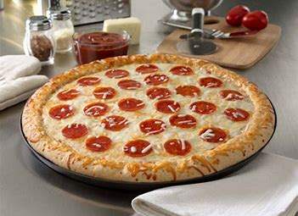](https://www.bing.com/images/search?view=detailV2&ccid=RooI1VY%2b&id=CA42B2F6CB22D947ADC8955A9AE71E2BC38EF897&thid=OIP.RooI1VY-zneMz4sOr2I0FQHaFj&mediaurl=https://s3.amazonaws.com/schwans.innovation.products/78986L&exph=375&expw=500&q=big+daddys+pizza&simid=608054207773674772&selectedIndex=1)

**Allergen Alert!**

**Contains wheat, whey, milk**

***Nutritional Information and Cost Per Serving:$.***

**Calories**

**Carbohydrates**

**Fat Total**

**Saturated Fat**

**Sodium**

***Components Per Serving:***

2 ounce whole grain; 2 ounce meat/meat alternate; 1/3 cup red orange vegetable

**Recipe Instructions and HACCP**

**\*CCP: wash hands thoroughly to prevent cross contamination before starting food preparation.**

**\*CCP: Use gloves when handling the pepperoni. Even though this is a cooked product, any left over**

**Pepperoni you return to the container must be untouched in case it is used in a RTE recipe.**

1. Thaw pepperoni under refrigeration 2-3 days before service.
2. Place pepperoni in a bowl/pan to allow easier access to the slices.
3. Pull up to five pizzas at a time to top.
4. Place 24 slices of pepperoni around the top of the pizza, spacing so each slice will get an average of 3 pieces of pepperoni
5. Spread one (1) cup shredded mozzarella on top of the pepperoni to help hold them in place during cooking and cutting.
6. Bake pizza according to manufacturer’s instructions. In a convection oven at 350 Degrees F. for 12-14 minutes.
7. Slice pizza in 8’s after cooking
8. Hold pizza in a hot holding unit at 140 or above for service.

**\*CCP Hot food held at 140 Degrees or higher.**