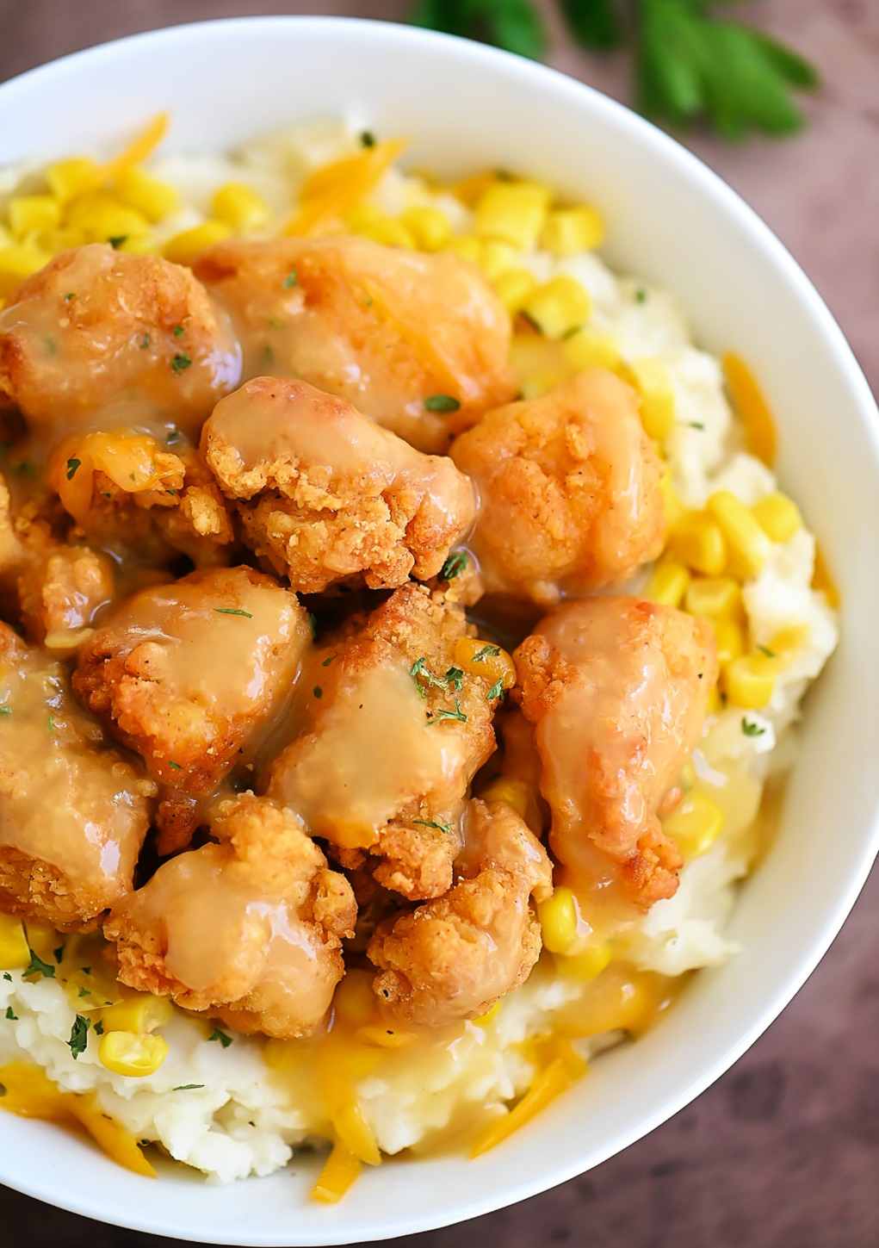 

**Royal Chicken Bowl Royal Chicken Bowl**

**Bowl**

**Royal Chicken**